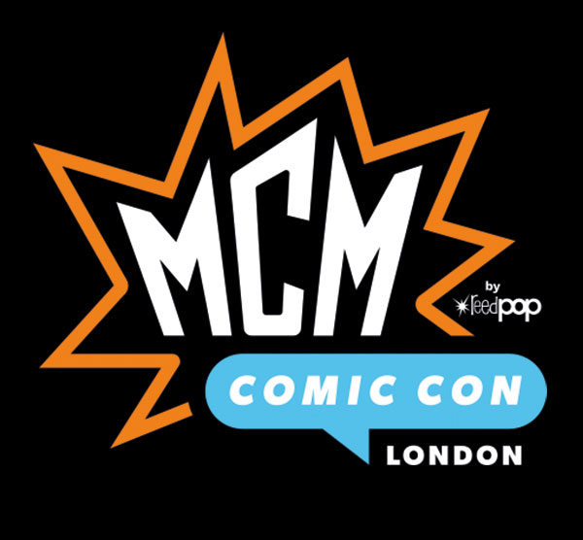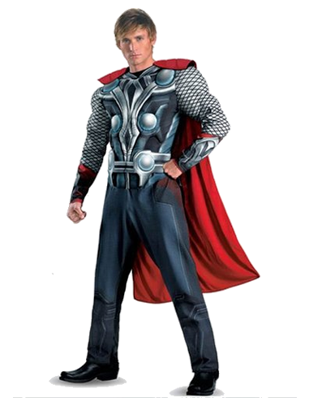

**@FancyThat**

**@FancyThat**

**"Leading fancy dress costume designers”**

**Fancy That will be attending the MCM Comic Con London, 2019.**

**Fancy That are using the up-and-coming exhibition to attract new customers who are fans of the show by showcasing past and current costume designs they have created for leading manufacturers around the UK.**

**Fancy That - fancythat@sky.com** **- 01932 797701**